

NATIONAL INSTITUTE OF TECHNOLOGY KARNATAKA

SURATHKAL, MANGALORE - 575 025

Course Code – CS254

Course Name – Database Systems Lab

Lab - 06

Date – March 23, 2022

Submitted To

Dr. Annappa B

Department of Computer Science and Engineering

National Institute of Technology Karnataka, Surathkal

Submitted By

Md Rakib Hasan

Roll – 201CS132

Department of Computer Science and Engineering

**1. Using employee database perform the following queries.**

**Employee(empid, empname, empemail, phone_no, salary, city)**

**(Add 10 entries for the table)**

CREATE DATABASE IF NOT EXISTS lab_six;

USE lab_six;

CREATE TABLE employee (

    empid INT NOT NULL AUTO_INCREMENT,

    empname VARCHAR(255),

    empemail VARCHAR(255),

    phone_no VARCHAR(30),

    salary INT,

    city VARCHAR(50),

    PRIMARY KEY (empid));

INSERT INTO employee

    VALUES (default, "Sunil", "sunil@gmail.com", "0123456", 90000, "Delhi"),

    (default, "Aadil", "aadil@gmail.com", "012424456", 20000, "Goa"),

    (default, "Vinay", "vinay@hmail.com", "01356456", 93000, "goa"),

    (default, "Felix", "felix@nomail.com", "022553456", 40000, "Delhi"),

    (default, "Kiran", "kiran@gmail.com", "53535353", 9000, "Bangalore"),

    (default, "Mohan", "mohan@yahoo.com", "3643253", 9500, "Mumbai"),

    (default, "Anaya", "anaya@gmail.com", "01234564", 80000, "Mumbai"),

    (default, "Parul", "parul@gmail.com", "01235758", 6000, "Bangalore"),

    (default, "Tunil", "tunil@gmail.com", "01239654", 80000, "Chennai"),

    (default, "Kunil", "kunil@yahoo.com", "0123443643", 2000, "Bangalore");

**a. Write a query to retrieve the number of employees in each city.**

SELECT city, count(*) AS total_employee

FROM employee

GROUP BY city

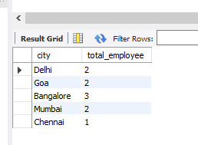

**b. Write a query to retrieve the number of employees having different salaries in each city.**

**c. Write a query to retrieve the number of employees in each city, sorted in descending order.**

SELECT city, count(*) AS total_employee

FROM employee

GROUP BY city

ORDER BY total_employee DESC

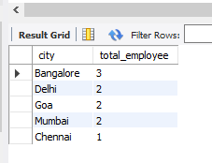

**d. Write a query to retrieve the salary of all employees, sorted in ascending order.**

SELECT empname, salary

FROM employee

ORDER BY salary ASC

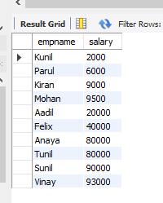

**e. Write a query to retrieve the number of employees in each city having salary > 30000**

SELECT city, count(*) AS total_employee

FROM employee

WHERE salary > 30000

GROUP BY city

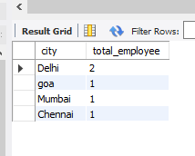

**f. Write a query to retrieve the details of all the employees who have gmail or yahoo account.**

SELECT *

FROM employee

WHERE empemail REGEXP 'gmail|yahoo'

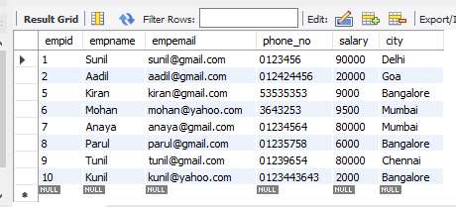

**g. Write a query to find the number of employees whose average salary is greater than 15000 and also print their names in ascending order.**

**2. Consider the Employee table.**

**(Add 10 entries for the table)**

CREATE TABLE emp_table (

    empid INT NOT NULL,

    empname VARCHAR(255),

    empdept VARCHAR(50),

    empsalary int,

    empcity VARCHAR(50));

INSERT INTO emp_table

    VALUES (2001, "Sunil", "Finance", 9000, "Delhi"),

    (2003, "Aadil", "HR", 8000, "Goa"),

    (2004, "Vinay", "Coding", 7000, "Bangalore"),

    (2005, "Felix", "Coding", 7500, "Mumbai"),

    (2006, "Kiran", "HR", 8500, "Mumbai"),

    (2007, "Mohan", "Marketing", 6500, "Bangalore"),

    (2008, "Anaya", "Coding", 7000, "Chennai"),

    (2009, "Parul", "Finance", 8500, "Bangalore"),

    (2010, "Aunil", "HR", 6200, "Delhi"),

    (20011, "Bunil", "Coding", 6000, "Goa"),

    (2012, "Cunil", "Finance", 7400, "Chennai"),

    (2013, "Dunil", "Marketing", 7300, "Mubmai"),

    (2014, "Eunil", "HR", 7800, "Delhi"),

    (2015, "Funil", "Finance", 7200, "Bangalore"),

    (2016, "Gunil", "Finance", 9700, "Goa"),

    (2017, "Hunil", "Marketing", 5000, "Delhi"),

    (2018, "Iunil", "Finance", 3500, "Delhi")

**a) Add the salaries of employees of each city**

SELECT *, COUNT(*), SUM(empsalary)

FROM emp_table

GROUP BY empcity

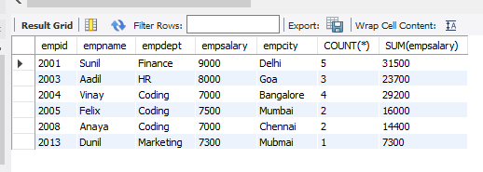

**b) Show those cities whose total salary of employees is more that on equal to 8000**

SELECT *, COUNT(*), SUM(empsalary) as total_salary

FROM emp_table

GROUP BY empcity

HAVING total_salary >= 8000

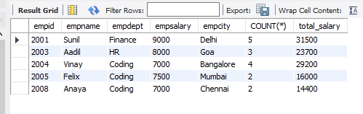

**c) Show each department and the minimum salary in each department.**

SELECT empdept, MIN(empsalary)

FROM emp_table

GROUP BY empdept

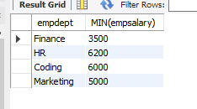

**d) Show only those departments whose minimum salary of employees is greater than 7500**

SELECT empdept, MIN(empsalary) AS min_salary

FROM emp_table

GROUP BY empdept

HAVING min_salary>7500

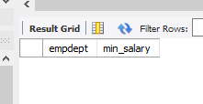

**e) List each department and the maximum salary in each department.**

SELECT empdept, MAX(empsalary) AS max_salary

FROM emp_table

GROUP BY empdept

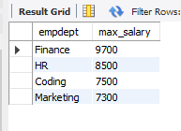

**f) Show only those departments whose maximum salary of employees is less or equal to 7000**

SELECT empdept, MAX(empsalary) AS max_salary

FROM emp_table

GROUP BY empdept

HAVING max_salary<=7000

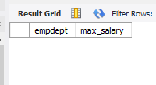

**g) Find the average salary of employees in each department.**

SELECT empdept, AVG(empsalary) AS avg_salary

FROM emp_table

GROUP BY empdept

